**MDRANS DELEGATE REGISTRATION**

**Sept 12-14, 2025**

**Best Western Plus, Bridgewater, Nova Scotia**

Delegate Name: ____________________________________

Facility: ___________________________________________

$-70.00 Membership # _____________

$-120 non-member: _____________

Send registration form to:

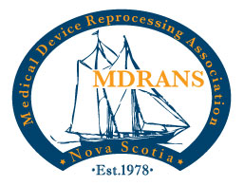

[Mdrans1@hotmail.com](mailto:Mdrans1@hotmail.com)

E-transfers can be sent to: [mdrans1@hotmail.com](mailto:mdrans1@hotmail.com)

If you will be bringing a guest to the buffet dinner, there is a $50.00 additional fee.

Total number of guests attending dinner: _______________

Deadline for registering a guest for the meal is: Sept 1, 2025

There will be no refunds issued.